

**Version 1.0.0.6**

Contents

Author 2

Introduction 2

Demography 2

Idea to Software 3

EXPECTATION 3

Installation 3

First Run 5

Switching to another Lotto Game 10

Getting the latest Draw Dates 11

Setup Lotto Outlet first 13

Adding your bet 14

Modify existing bets 18

Managing Claims 21

Move the target draw date of your bet 25

Pick Generator 27

Hit Comparison 30

Dashboard 32

Reports 33

Machine Learning 35

Lotto Data Manager Updates 36

# Author

* Ryan Seth Roldan

# Introduction

* Lotto Data Manager has been brought to life to assist the user to manage his luck, money, and time in playing the Lotto.
* There are times you cannot pick anymore a number because of frustration. This software will let you help to choose a random number using Pick Generators as your bet.
* You can monitor your average spending per game.
* You can see the latest draw result without searching on the internet.
* It can assist you to manually pick your next number by having highlighting the pattern of drawn numbers on your bet versus the drawn result.

# Demography

Unfortunately, this has been programed locked on Philippine Lotto Game only as I only know how to play the games within the country.

# Idea to Software

When you are into playing the lotto game, you will sometimes wonder if you choose the most appropriate number pick as your bet following your divine ritual number pattern astrology technique. Frustration will follow that none of your chosen numbers will be drawn as results.

In your simple analysis, you tend to find a pattern on how a number has been drawn comparing it to the previous result. By formulating your own pattern analysis and comparing it to the historical drawn result, you were always hitting the right number once, twice, or thrice.

This software will specifically show you the simple pattern of picking up a random number as your bet, and how frequent a certain number has been drawn compare to previous drawn results.

# EXPECTATION

* WHAT EVER THE RECOMMENDATION ON THIS SOFTWARE AND ITS GIMMICK TO ENTICE YOU TO PICK UP A GENERATED NUMBERS AS YOUR BET, THAT WILL STILL BE A RANDOM NUMBERS AT BEST.
* DON’T HOPE THAT THIS WILL BE YOUR GATEWAY TO RICHEST.
* AT THE END OF THE DAY, LOTTO GAME IS A FAIR GAME NUMBER!!!

# Installation

1. Download the latest release on GITHUB

<https://github.com/AngelsSoftwareOrg/LottoDataManager/releases/>

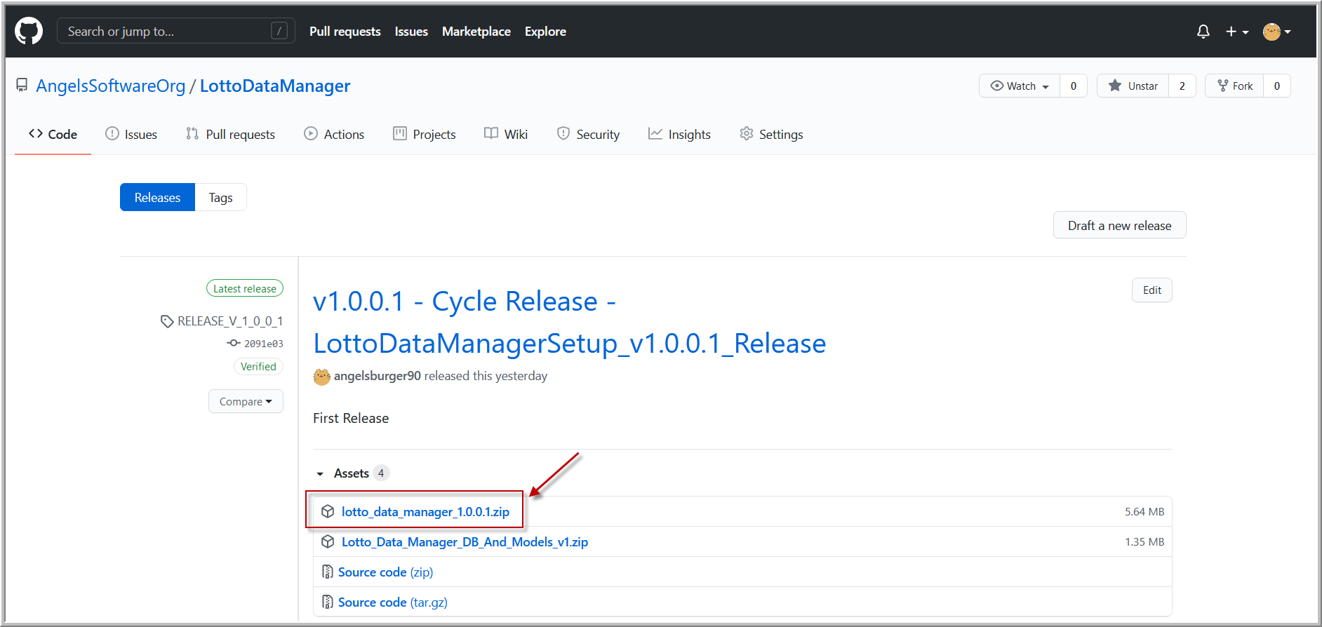

1. Extract the content of the zip file

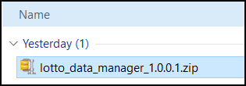

1. Double click to run the installer

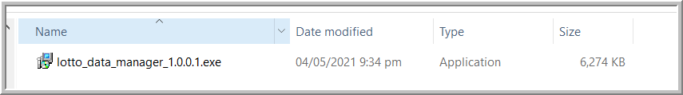

1. After installation, DON’T RUN IT YET

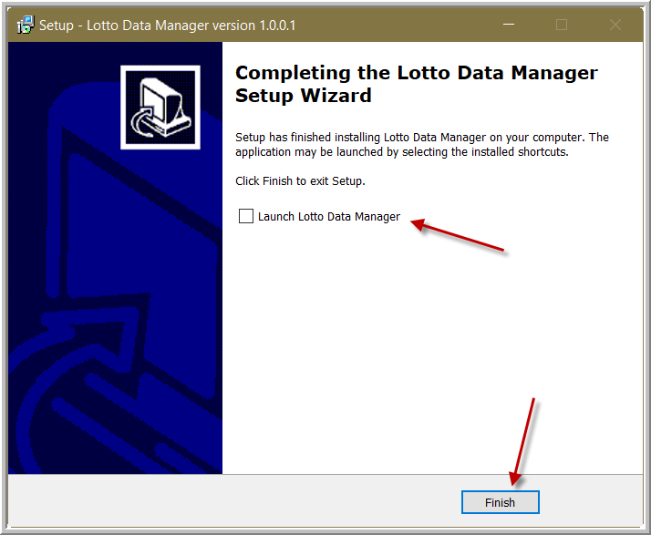

1. Download and install first the Microsoft Access Engine redistributable

<http://www.microsoft.com/en-us/download/confirmation.aspx?id=13255>

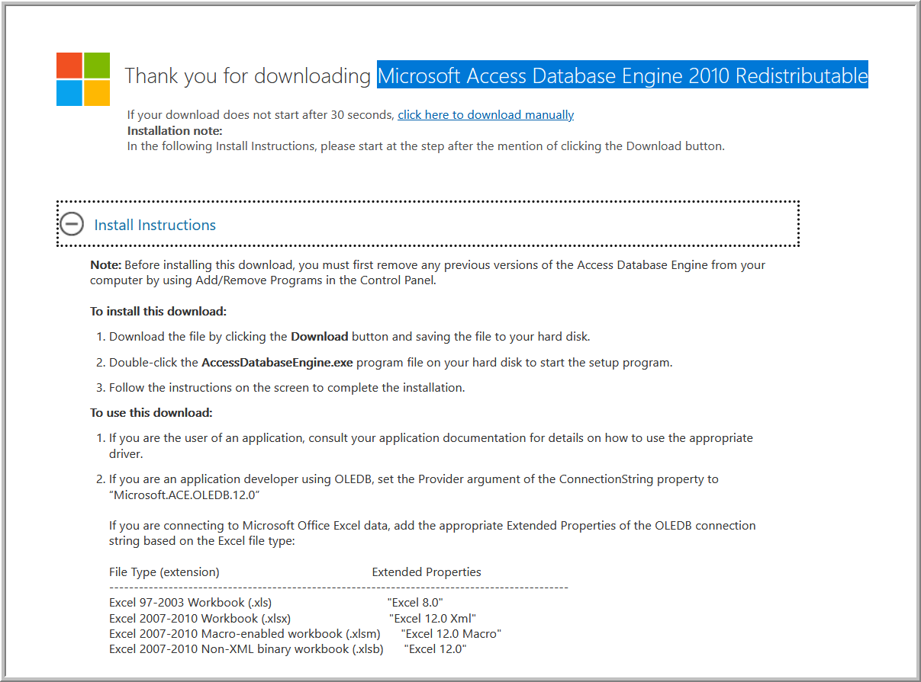

1. Then, try to running the program

# First Run

1. Run the program

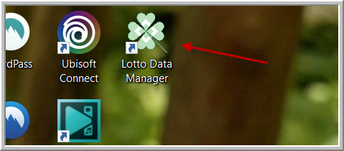

1. You will be prompt to point the database and machine learning models to use

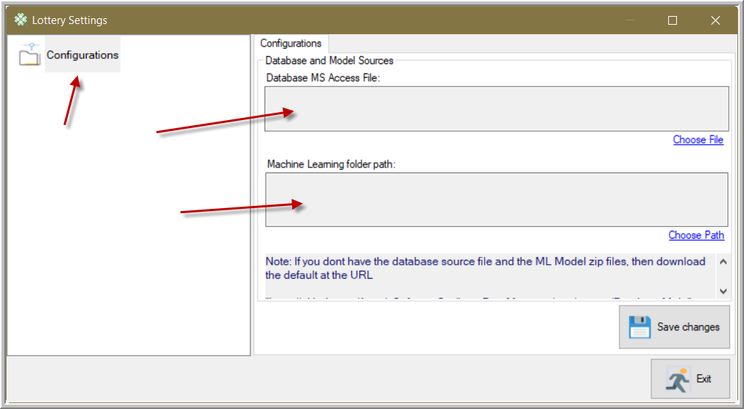

1. Back again on the latest release on GITHUB

<https://github.com/AngelsSoftwareOrg/LottoDataManager/releases/>

Download the Database and Models as highlighted below

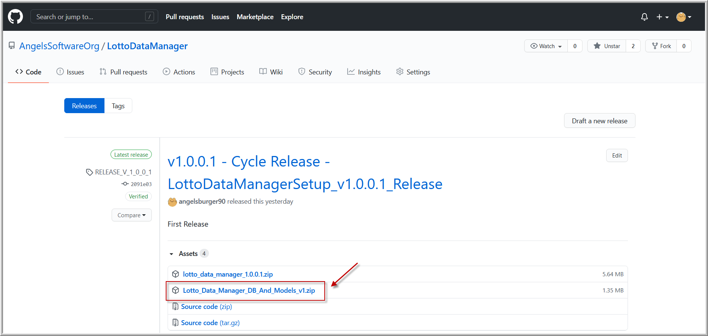

1. Extract the content of the zip file to your safe and comfortable location

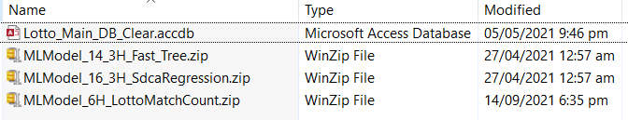

1. Going back to the main app, locate and place the Lotto Data Manager Database

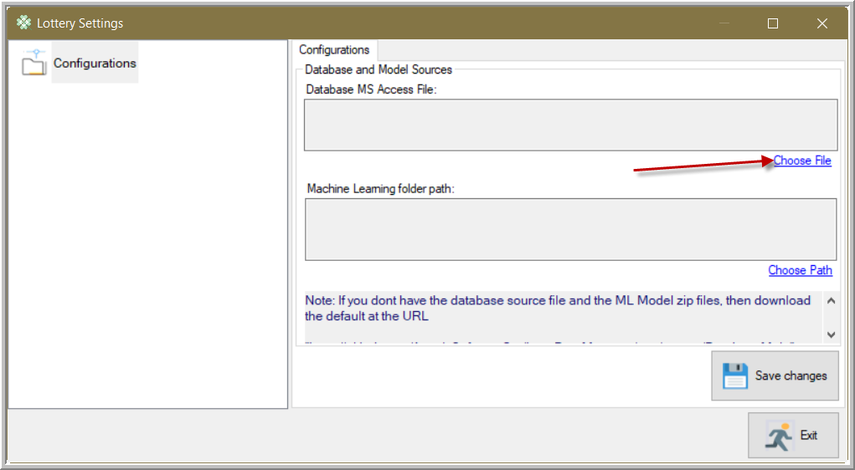

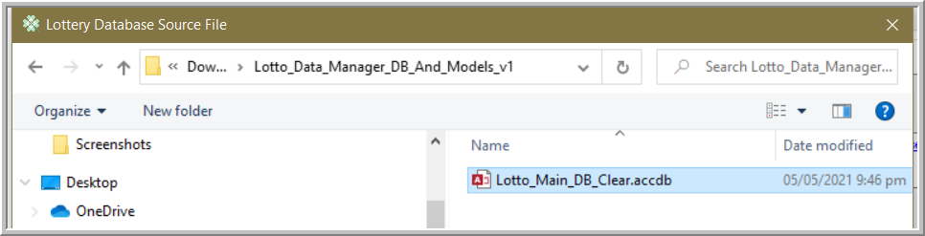

1. For the Machine Learning models, point the folder wherein the zip files below are

These were several Machine Learning models. Point the location wherein these are.

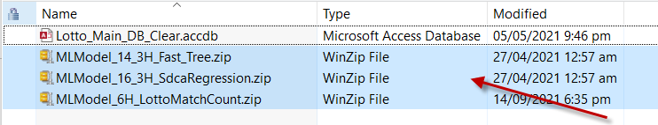

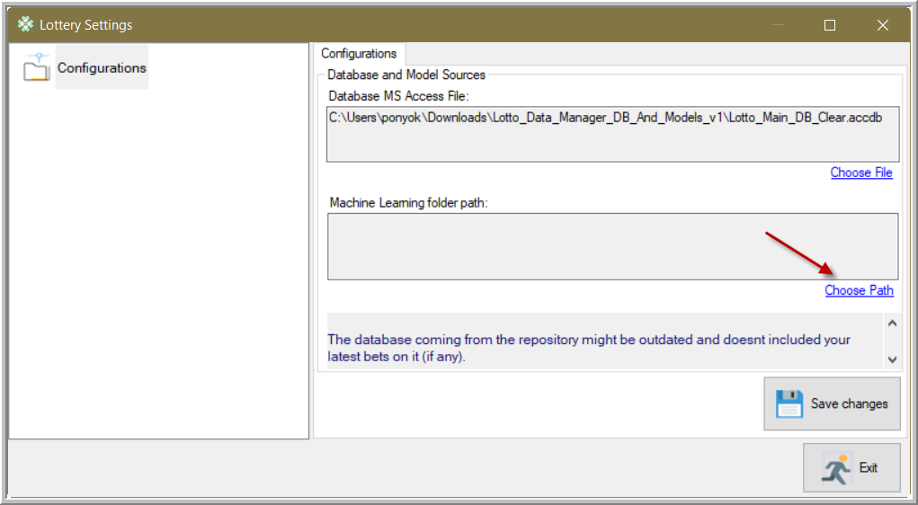

1. Then save your changes, and exit

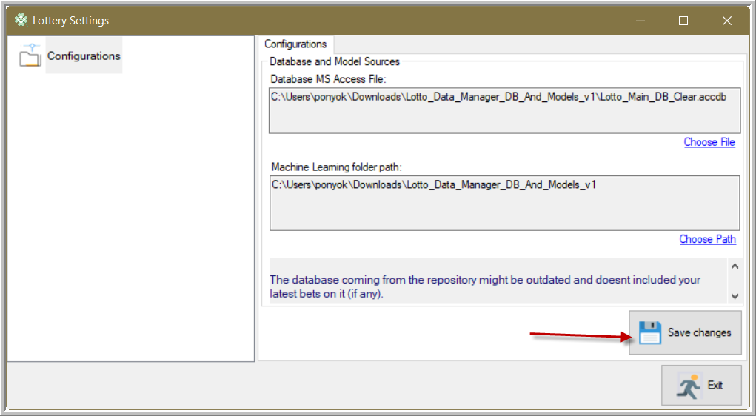

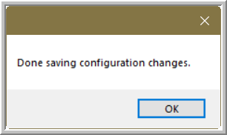

1. The main app will show up

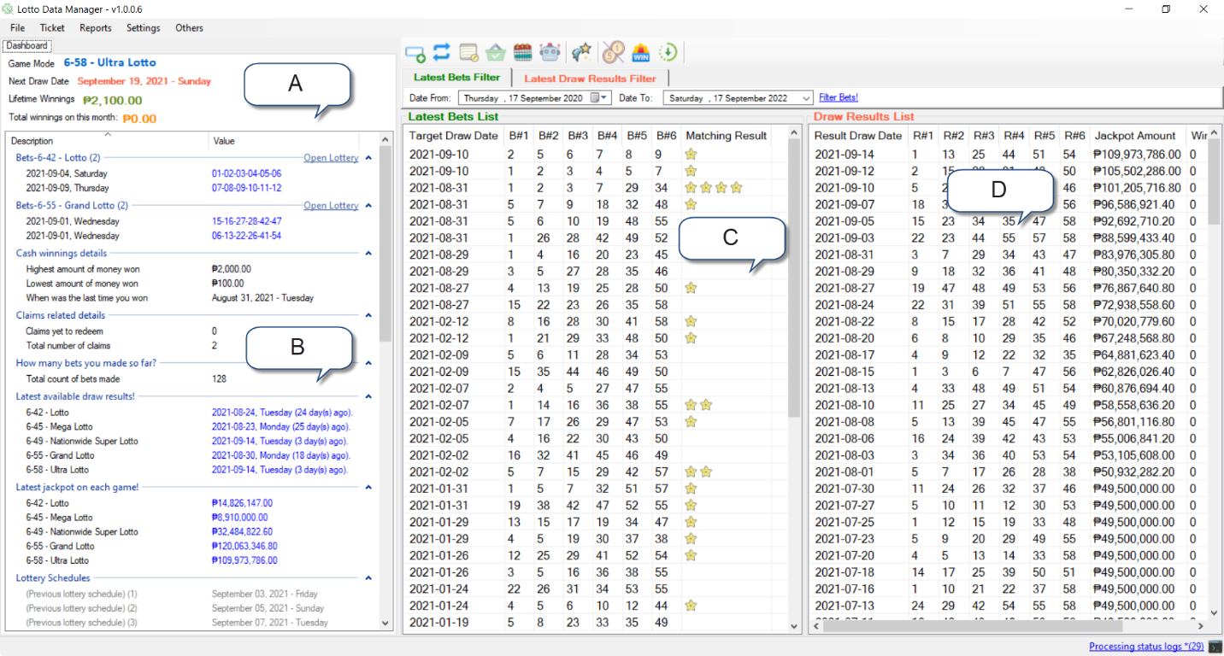

1. The current selected Lotto game you are managing
2. The quick dashboard to quickly see how you progress so far, and other information’s that might be helpful to you
3. The main board that displays your bets so far. It will display your bet record starting from one year ending today
4. The lotto draw result. It will display the resulting draw record starting from one year ending today

# Switching to another Lotto Game

Switching to another game is easy

By following the selection below, choose another game

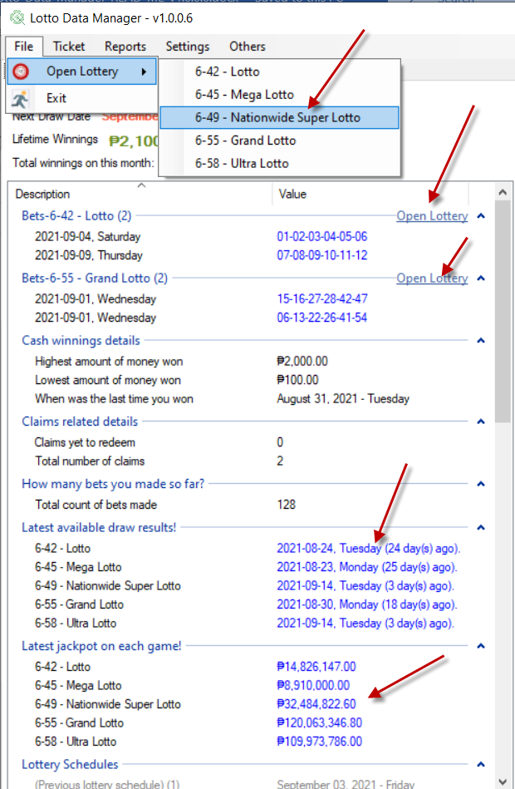

# Getting the latest Draw Dates

Getting the latest draw dates on the current selected Lotto game is easy

Click either of the two with the same Icon as shown below

1. From Others Menu -> Check Lottery Updates
2. From the standard tool bar

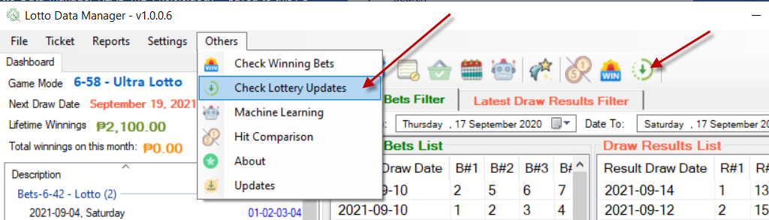

Upon clicking the update button, the app will start to scrape for the latest draw date.

To follow what’s happening on the background, click the status log on the bottom right for the latest activity

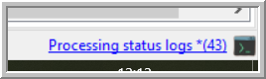

The logs will show you that it will only scrape result for the currently playing game which is 6-45

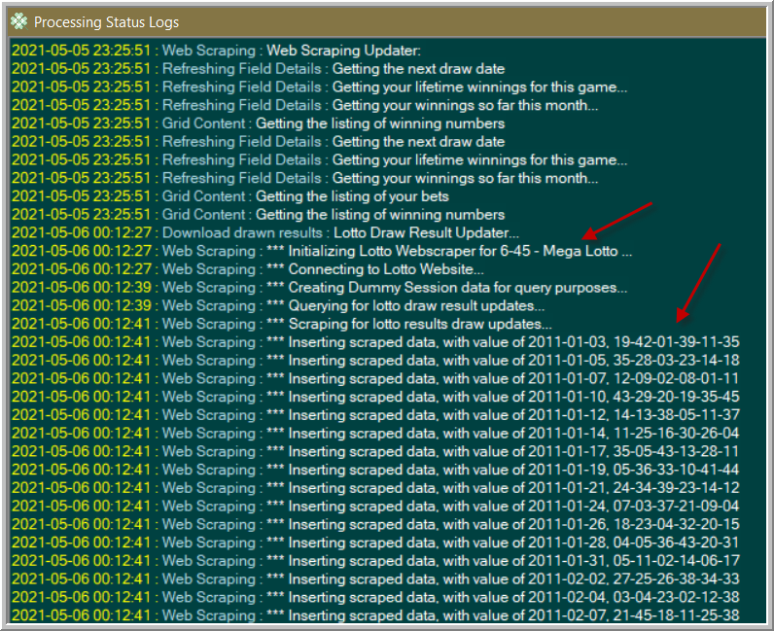

Exit the log status screen to go back to Main Form.

Here, it will display by the default the last one year drawn result data.

You may want to expand or narrow the listed results.

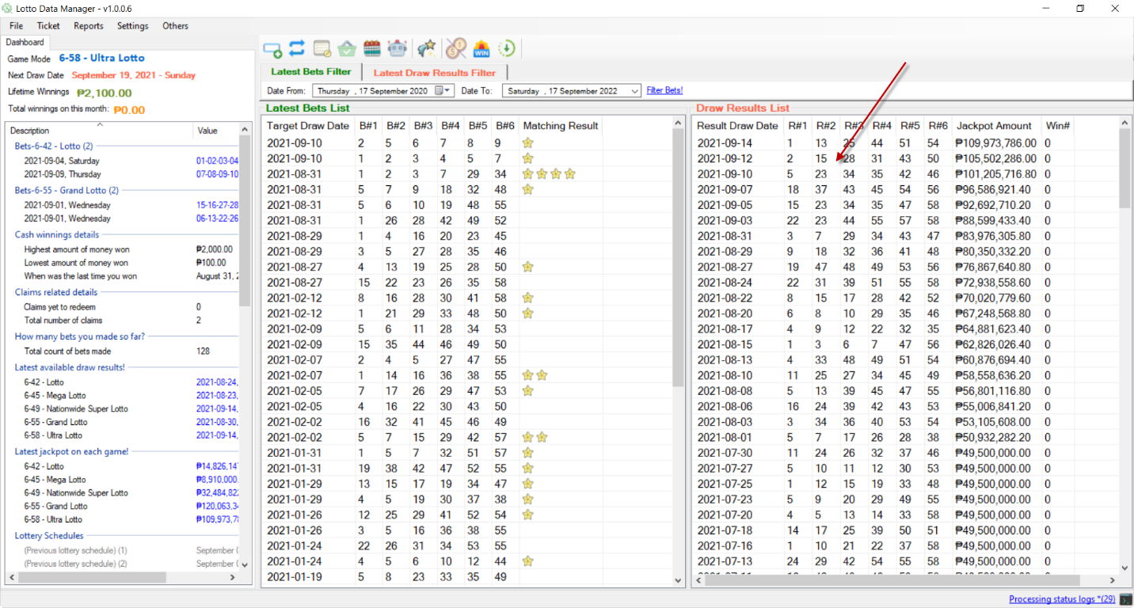

# Setup Lotto Outlet first

Setup your Lotto Outlet first because to ensure it will correctly place a right statistic which outlet generates most of your luck, by recording your bet and matching on the drawn results.

* Click Lottery Settings

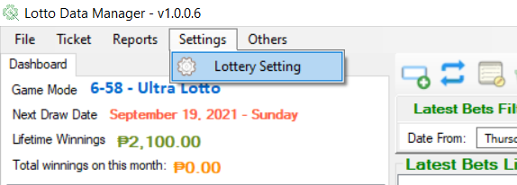

* Click the Lottery Outlet menu node on the left

The default outlet was “others” to record any outlet you forgot the place is

In the empty text box, you can put your new outlet there and hit save.

You can also modify the existing outlet by clicking one of the descriptions on the list, modify the description on the textbox and hit “Save modified outlet description”

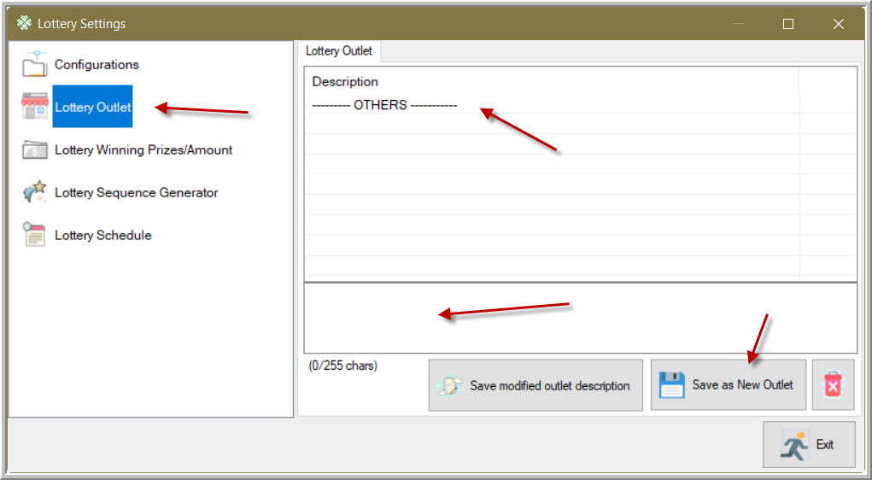

* After adding new lotto outlet

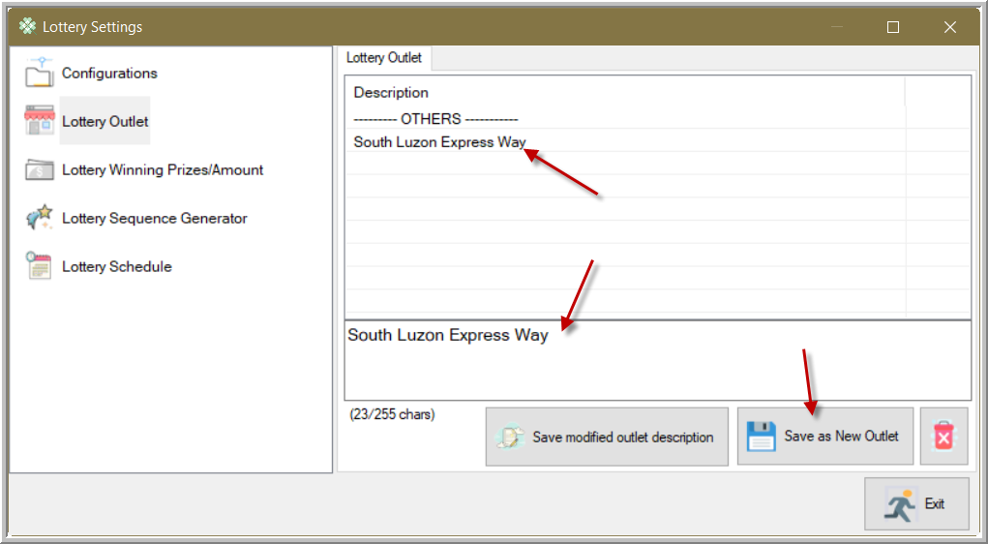

# Adding your bet

There are two ways to add your bet

1. Multiple bets
2. By input card layout

* Multiple Bets

Adding multiple bets is easy

1. Click either of the following, either by the menu or by the shortcut bar

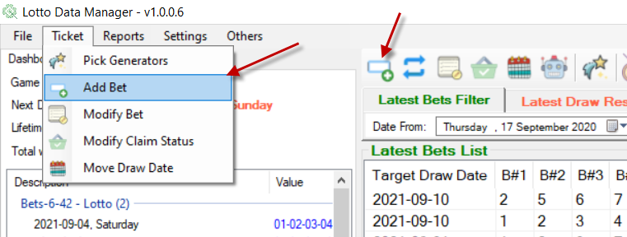

1. Click the first tab to input multiple bets at once

Place your bets separating numbers in allowed separator character

For now, choose the Next Draw Date to set your bet to

Pick you lotto outlet where you buy your Lotto Ticket

For this one, I choose this number randomly, so it’s my “Personal Pick” as my Pick Type

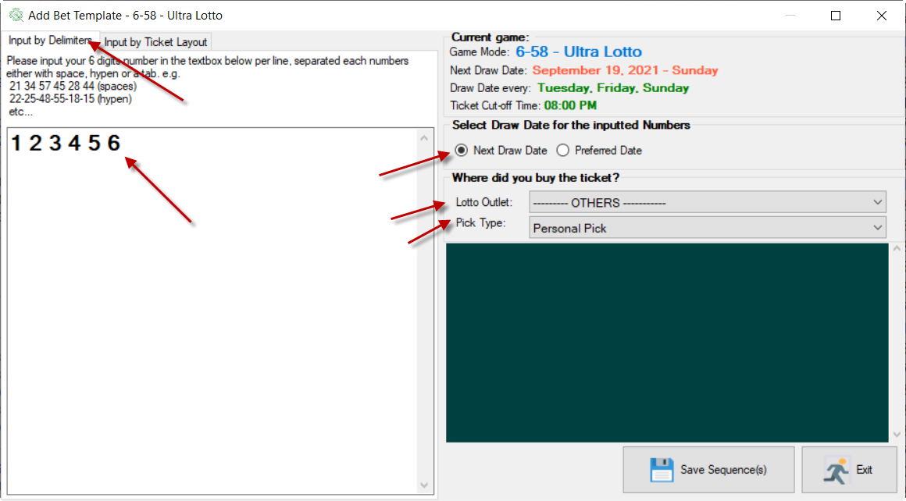

1. Clicking save will prompt you to double check your inputs. Hit ok if you’re satisfied

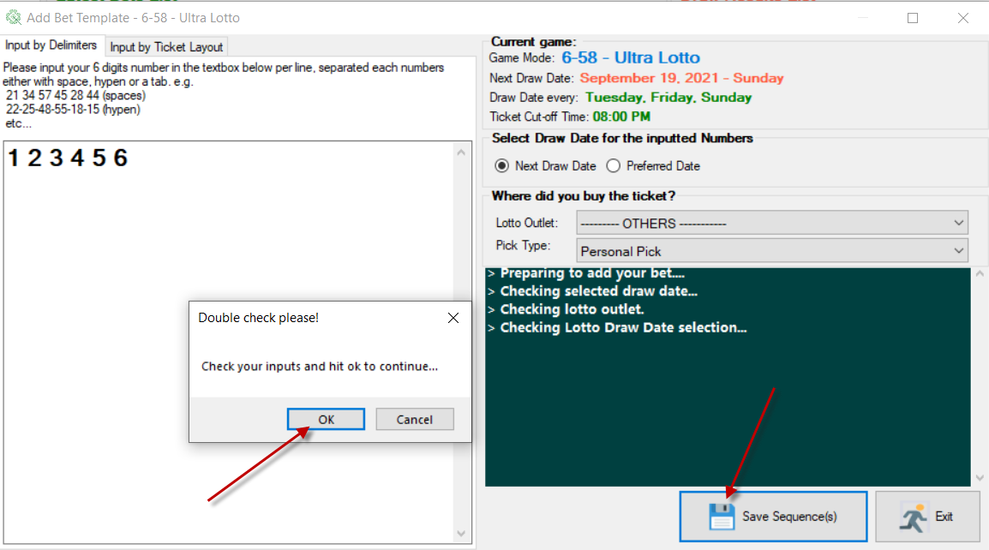

1. Saving your bets successfully

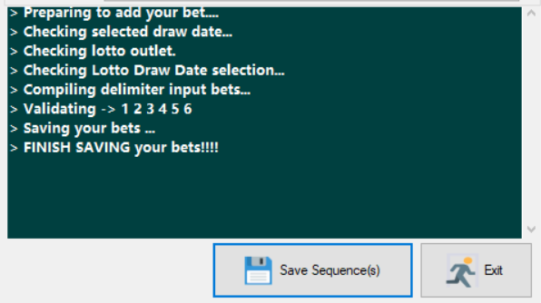

1. Return to Main Form, and the latest bets will display over there.

Your bet has been scheduled on September 19, but the latest result draw date is on September 14.

To update the draw result, click the Update button to let it save the latest draw date result.

It will automatically matchup the matching number from your bet from the drawn result.

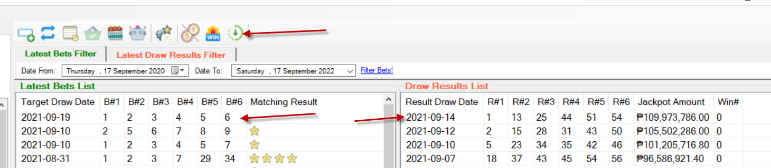

* Input card layout

1. When adding a new bet, click the 2nd tab

The numbered buttons below are layout like what on the actual ticket paper.

Select your numbers as your bet.

This time, we can only place one bet.

For the draw date, we put a previous draw date. In this case, the bet we put is a historical bet.

Save your bet and exit

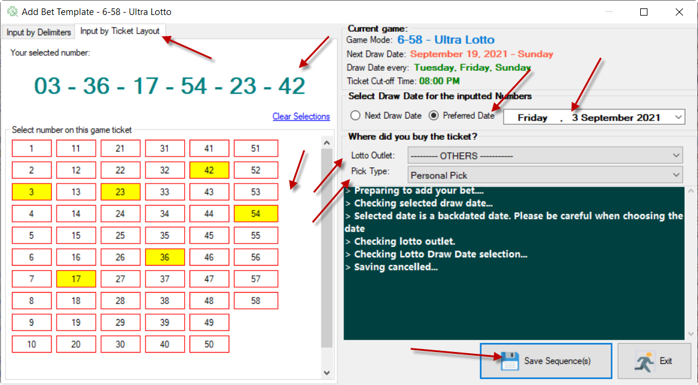

1. Upon exiting on the Add Bet Form, your numbers have been placed on the bet list and automatically matched to draw results making it mark that there’s a 4 matching numbers.

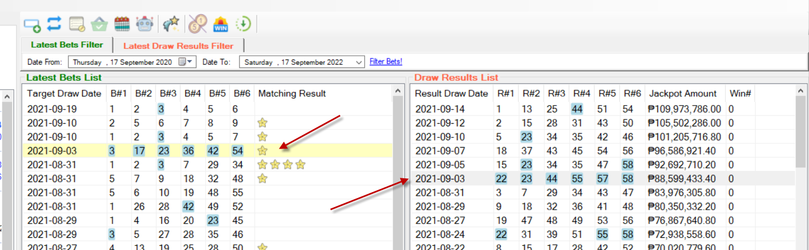

# Modify existing bets

To modify existing bet, click either of the following 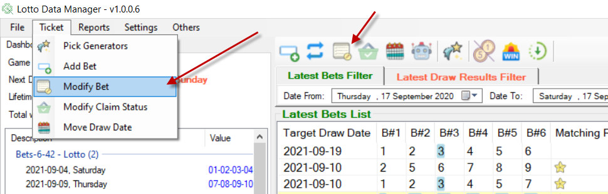

Or select a bet on the list, click the right mouse and select the menu as shown below

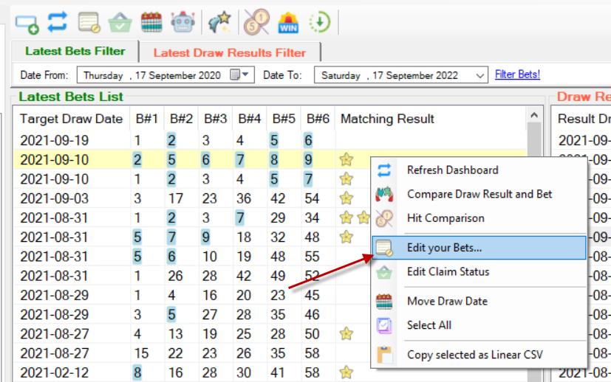

You can only modify the following columns content

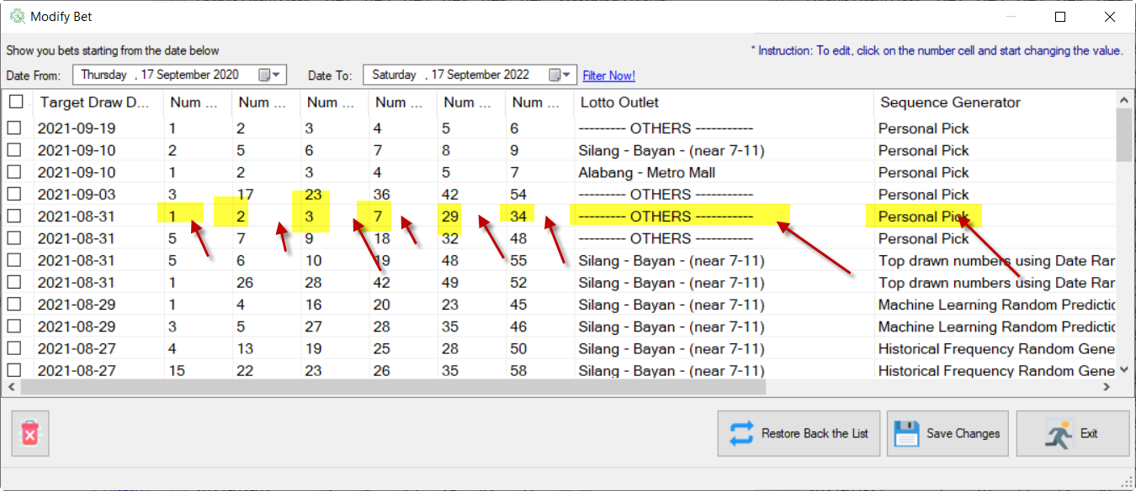

A modified entry will be Red highlighted. If you are satisfied with the change, then click Save button

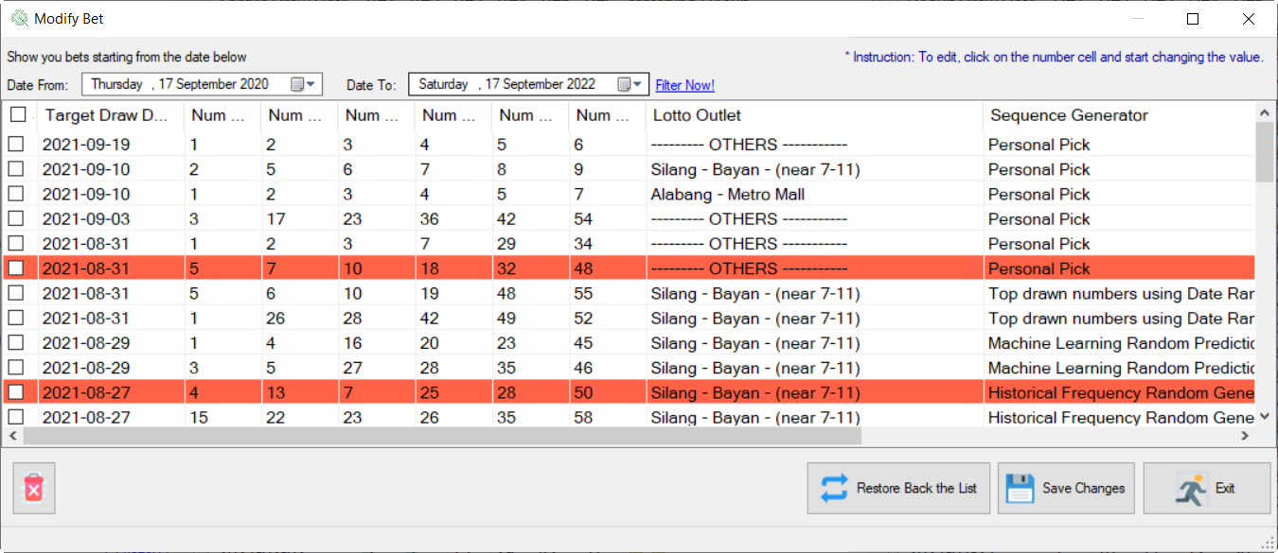

Your changes have been shown on the list

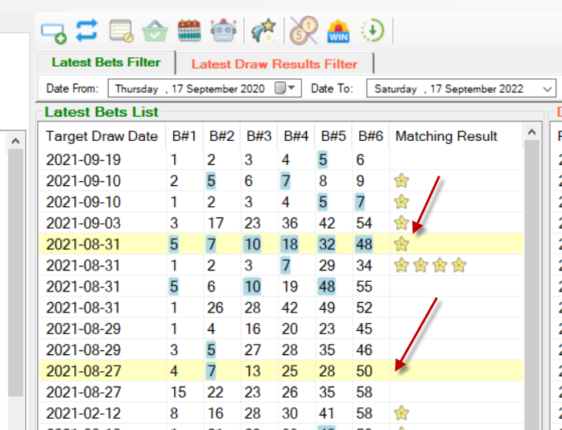

# Managing Claims

In case you won a minimum number on a bet matching the drawn result, then you won monetary prize. To track this one, you must let the app do a scan to record it.

In this example below, we have a single bet won 4 digits matching on the draw results.

To make it claimable on the app, click either “Check Winning Bets” or the shortcut button.

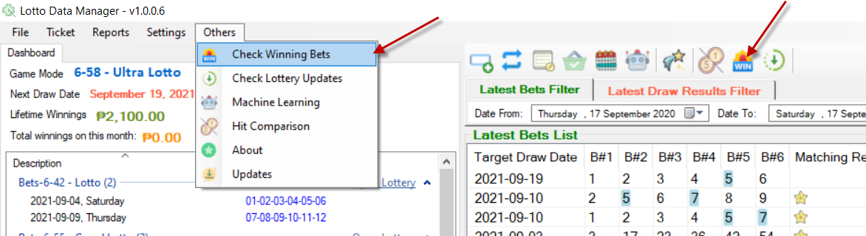

After scanning your bets, there would be an indicator how many claims you needed to claim.

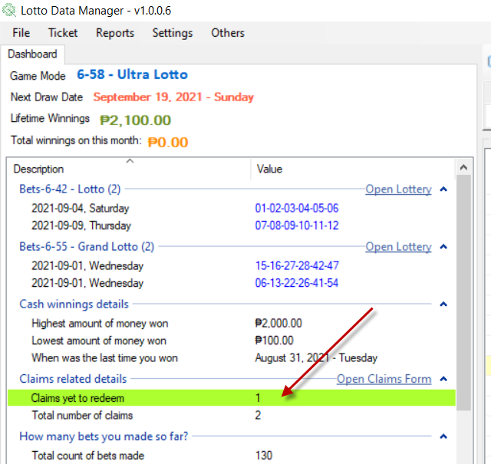

To manage your claim status, either click the “Green” colored list on the dashboard list or click either of the actions below.

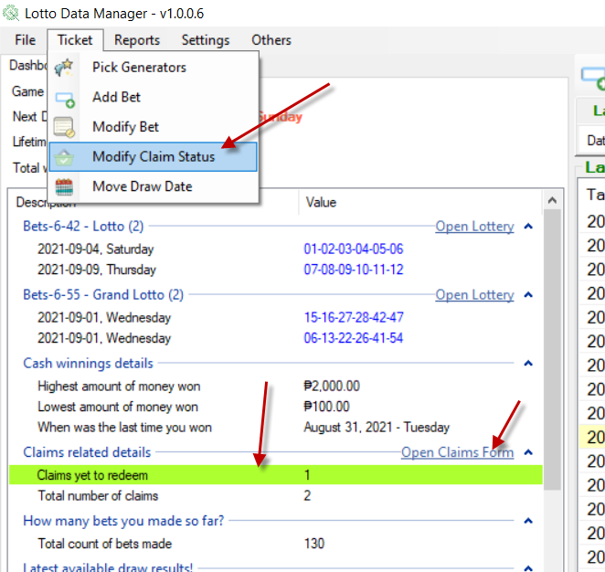

In this form, it was shown that the record has yet to put as “claimed” status.

Before you tag it as “Claimed”, make sure you already claimed it already on the Lotto Outlet or in the Lottery Main Office

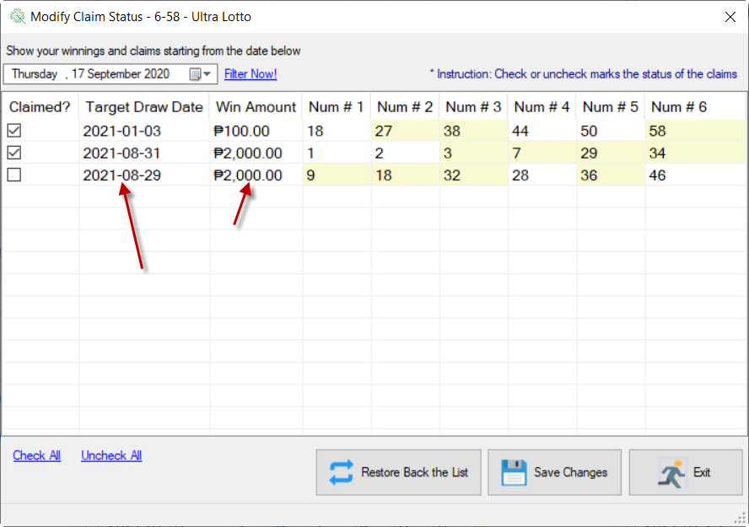

To make it to claimed status, make the target bet record “checked”, and then hit Save button.

Modifications will highlight the row to red.

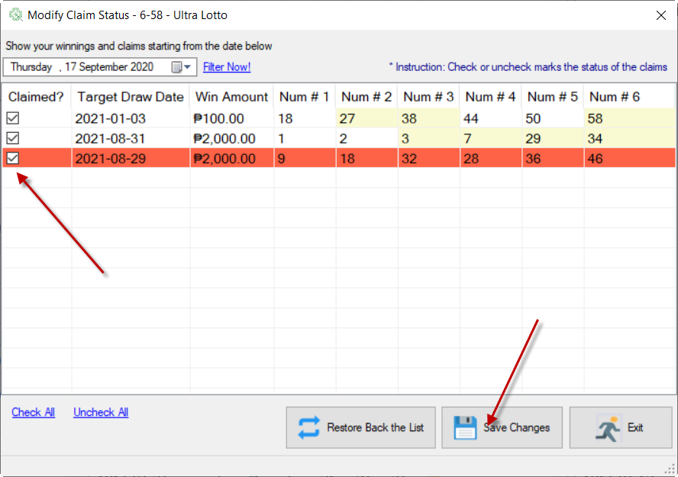

Exit the form and your lifetime winnings will be counted from now on.

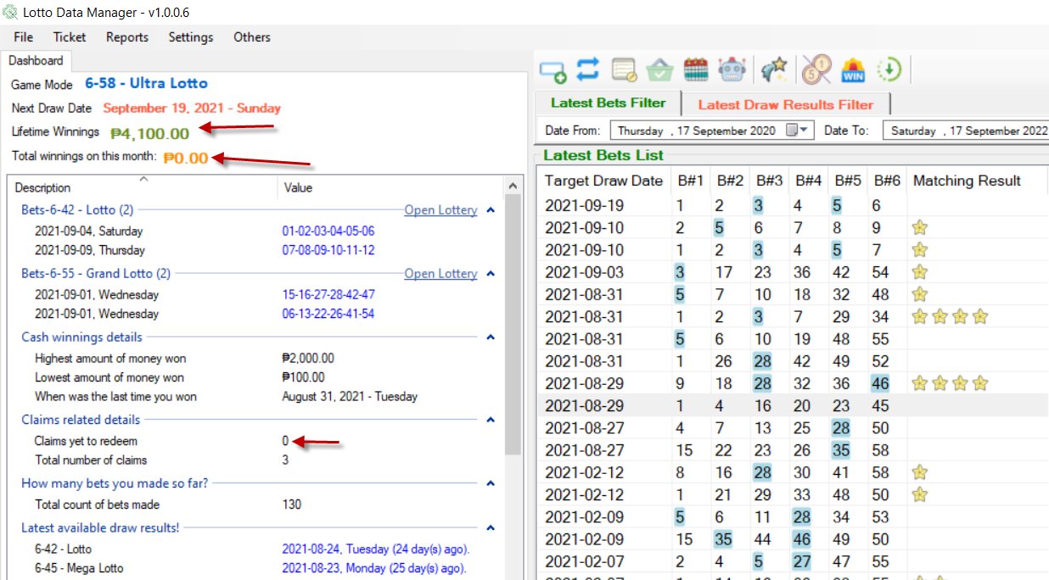

# Move the target draw date of your bet

If ever you forgot to bet on that day and decide that the same number sequences you put on your lottery ticket will be repurpose to target future Lottery Draw date, then this module will help you to move the record to another target draw date.

For starter, click either of the two below

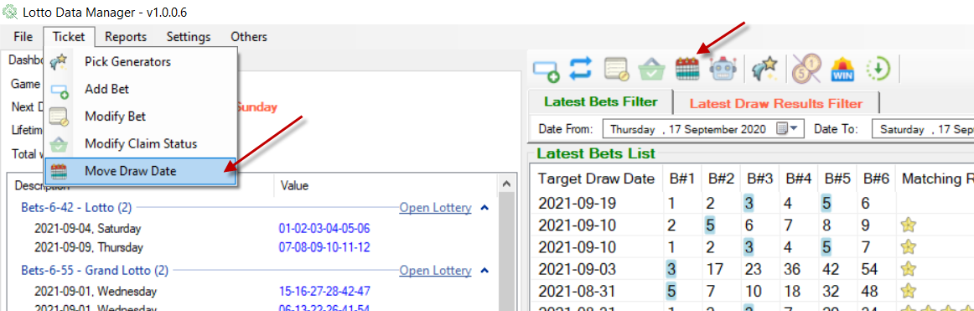

Select the bet you want to move the draw date.

Valid draw dates are varied depending on the selected Game Mode.

Select your new target Draw Date.

Then click save.

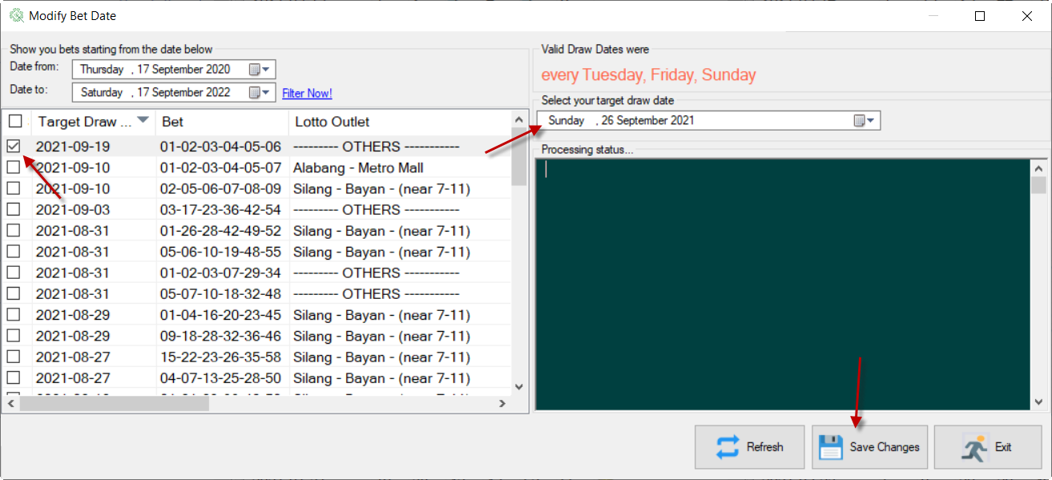

After modification,

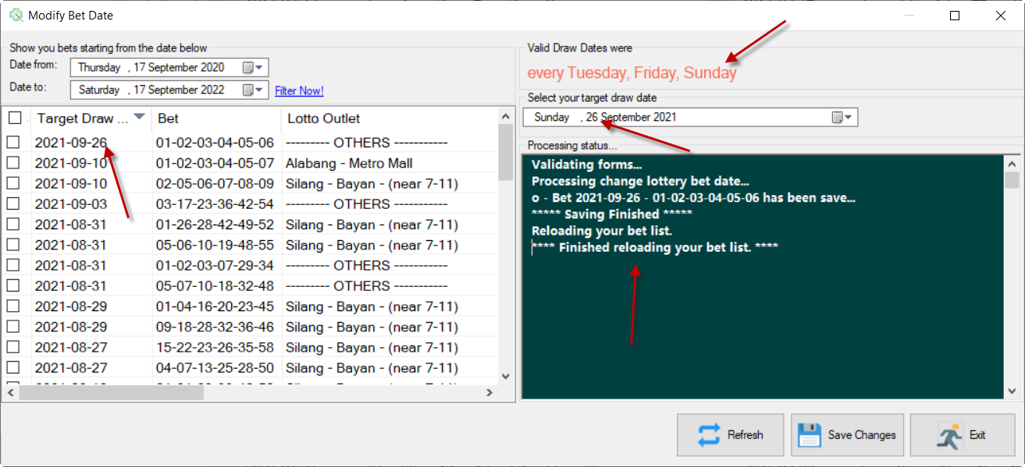

# Pick Generator

If you don’t want pick a set of numbers to put into your lottery ticket, Pick Generators module will help you do randomly generate a sequence of bet and choose to.

To start, click either of the following shortcuts.

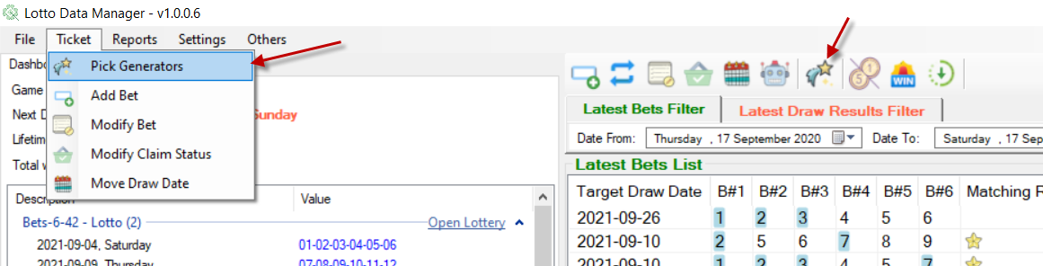

There are a numbers of Random Generators type that you can select and test that will suit your taste.

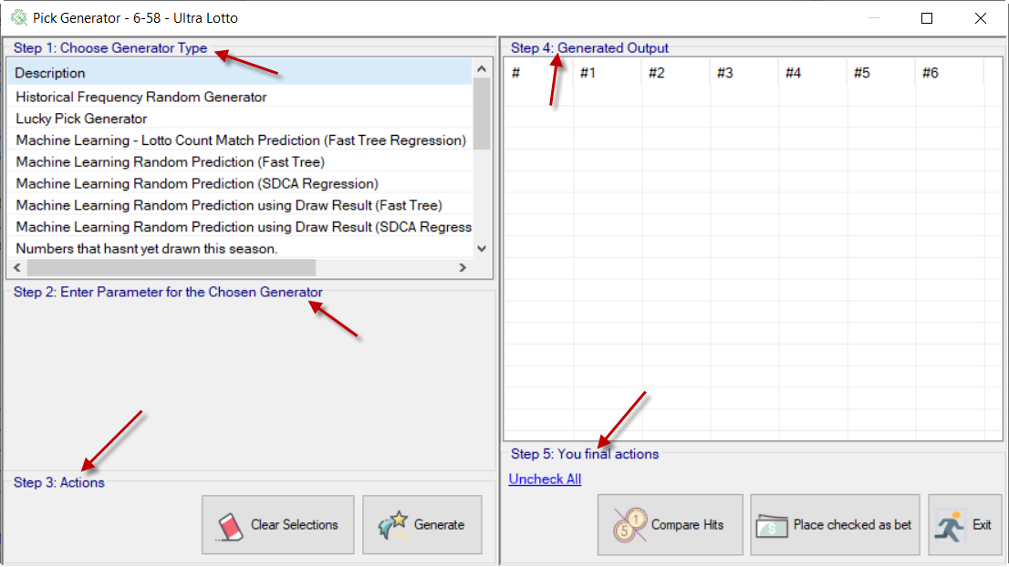

For the steps

1. Choose a Generator type that suit your taste whether this is a lucky pick, historically drawn numbers and randomly select a number on it, machine learning approach, drawn result pattern and many more.
2. There was generator type that requires some input parameters to setup how the sequence would be generated and how many would it be generated.

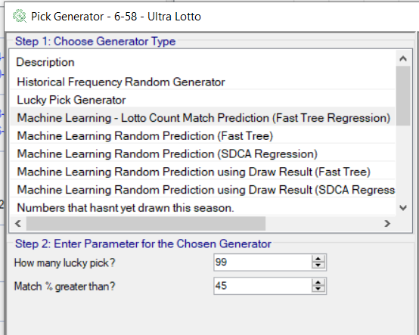

1. Actions you can do after selecting a generator type
2. The generated random sequence digits to choose as a bet

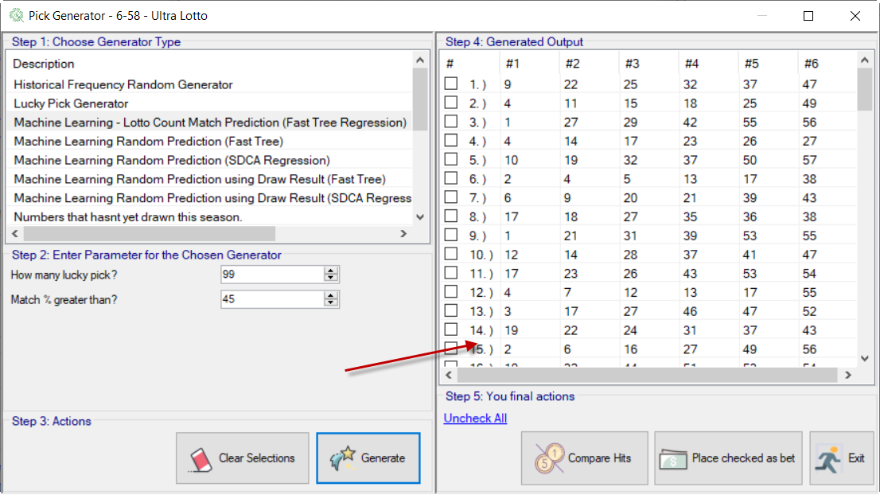

1. You can compare the generated random sequence number to the draw results by clicking the below button

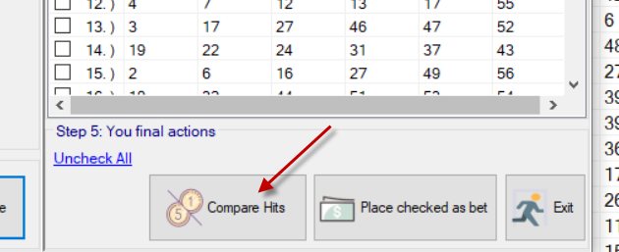

If you choose a number, it will compare automatically to drawn results.

This way, you can formulate which number should be choose based on your choice.

You can also try to check the checkbox so that on the Pick Generator form, it will auto check there.

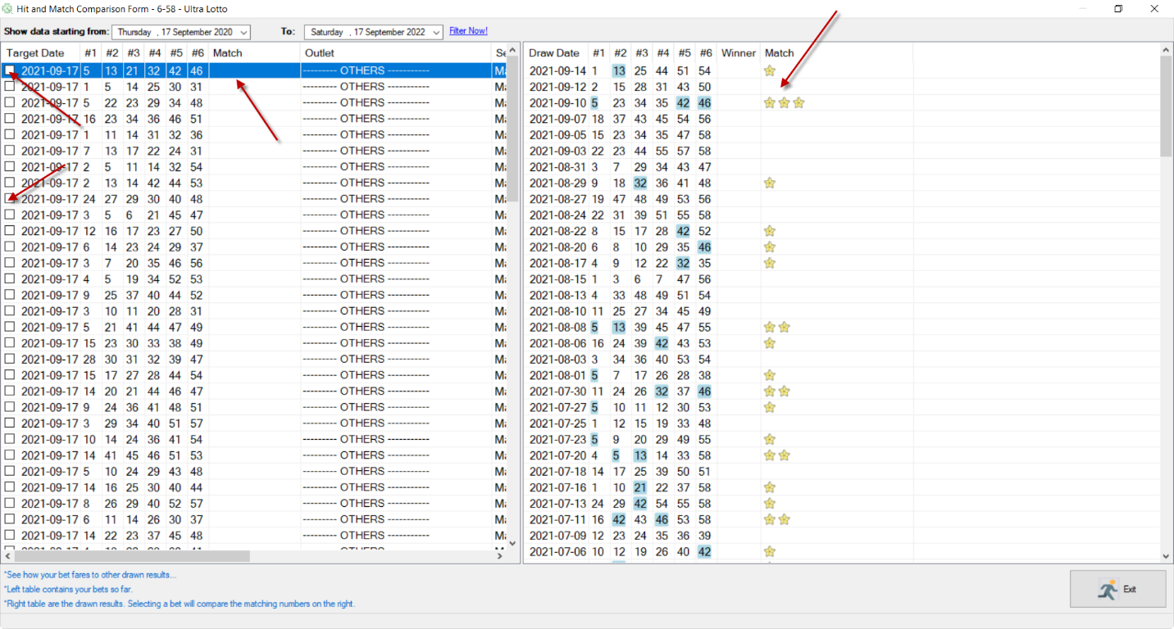

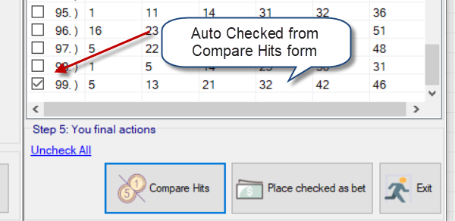

1. Final actions you can choose to. You can select a random bet and add it as your bet

When selecting thru the generated sequences as your bet, set it checked and click the “Place checked as bet” button

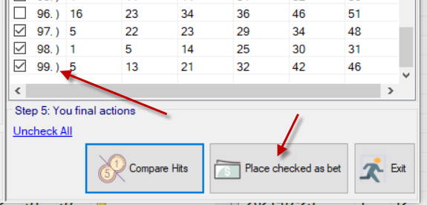

The selected sequences will be automatically put on the Add Bet template batch form, and set the corresponding generator type as Pick Type.

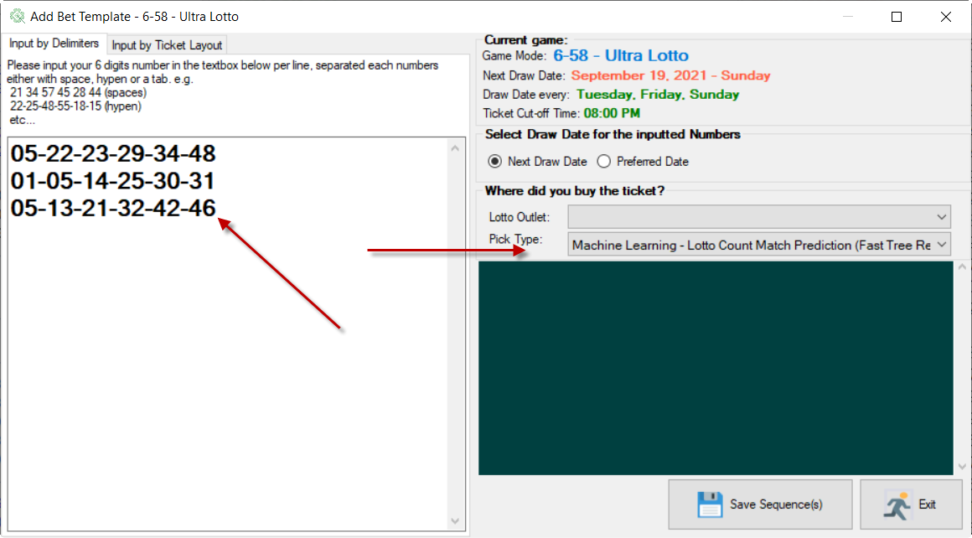

# Hit Comparison

Hit Comparison form is a new feature from version 1.0.0.2

It will let you compare your bet to the past drawn result and see how it fares.

To start with, click either of the menu below.

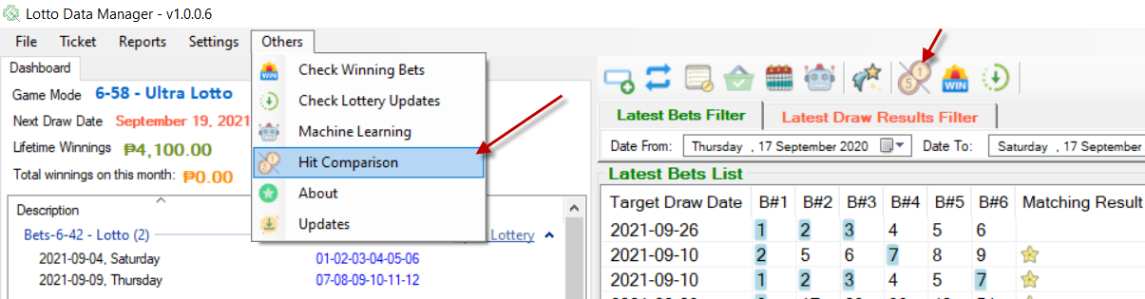

Hit Comparison has 2 tables visible.

**Left**: The table contains all your bets filtered thru by date

**Right**: The table contains all drawn result filtered thru by date

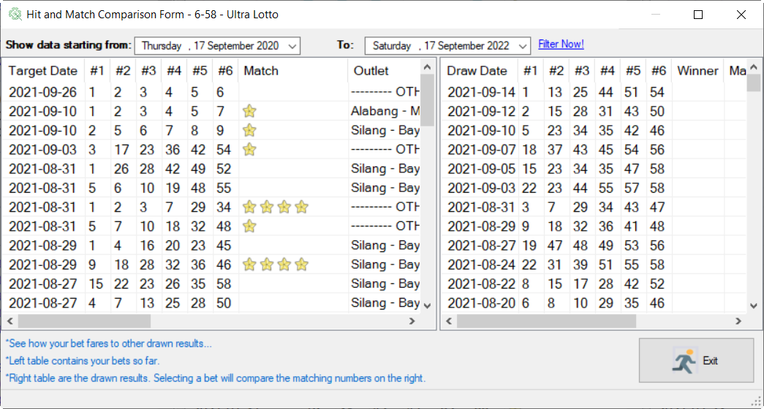

Clicking a bet will place a matching number on the right.

It will highlight all matching numbers on the drawn result and place the stars as an indicator of how many matched numbers there is acting like a quick glance.

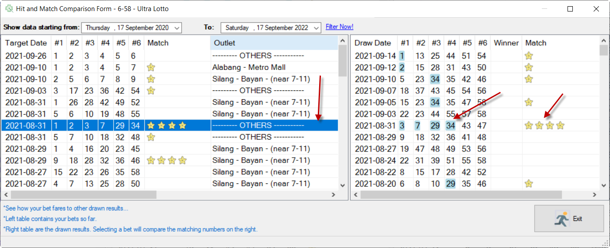

# Dashboard

Dashboard is a collections of a quick glance data/information’s that might help you to decide on your take to bet, or not to bet. It also helps to manage your spending decision by looking at you’re spending history by monthly or annually.

Most details on the dashboard are “What you see is what you get”. It is self-explanatory indeed.

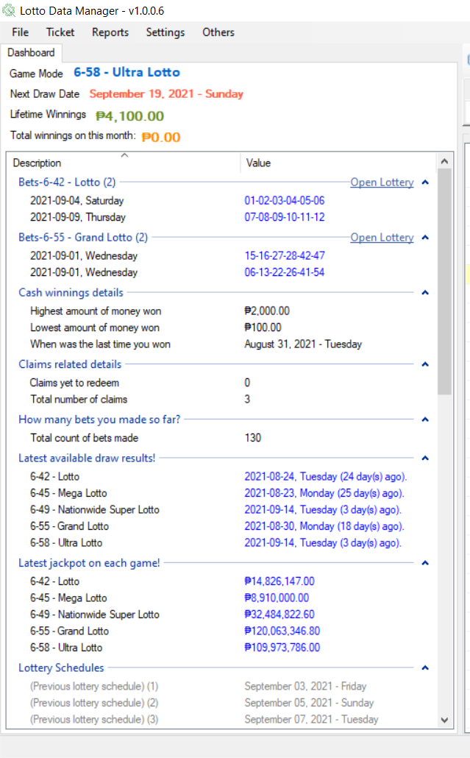

# Reports

To keep track your bet statistic and how its fare to drawn result, you may want to generate a Profit and Loss Report.

To start, click the “Profit and Loss” under “Reports” menu

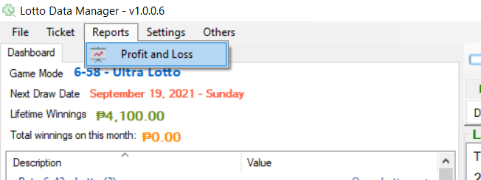

By default, the current game you are in will be selected.

But you can combine the statistic of other games if you want a whole new view.

For now, let the default selection be generated.

Click the “Run Report” button

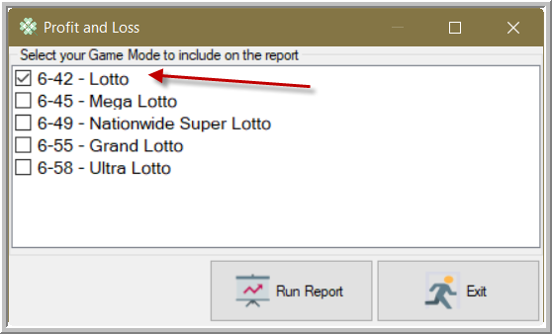

A browser will be pop up to display the generated HTML report.

Explore the statistic and see how you fare in your bet

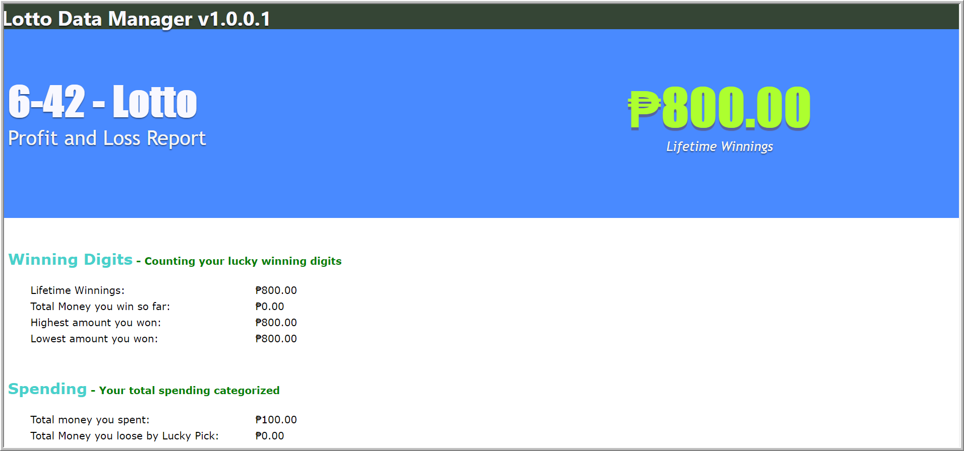

# Machine Learning

To keep the Machine Learning knowledge base up to date, we must feed it the latest drawn result data results.

The first requirement before doing the update would be you are keeping the latest Drawn Result records from PCSO saved on the database of this application.

To start to update the Machine Learning Model, keep either of the shortcut

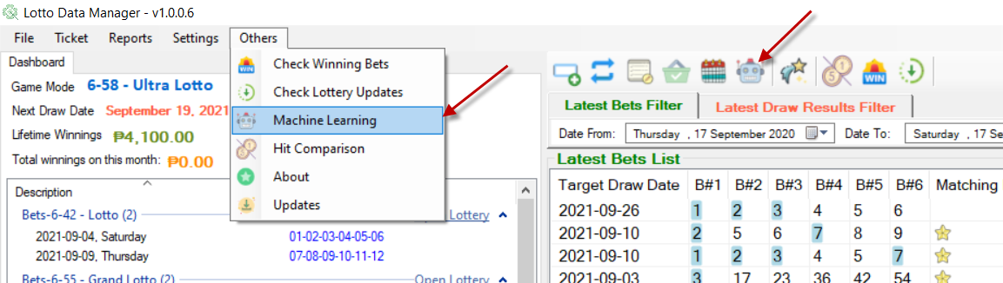

Click the button to start updating

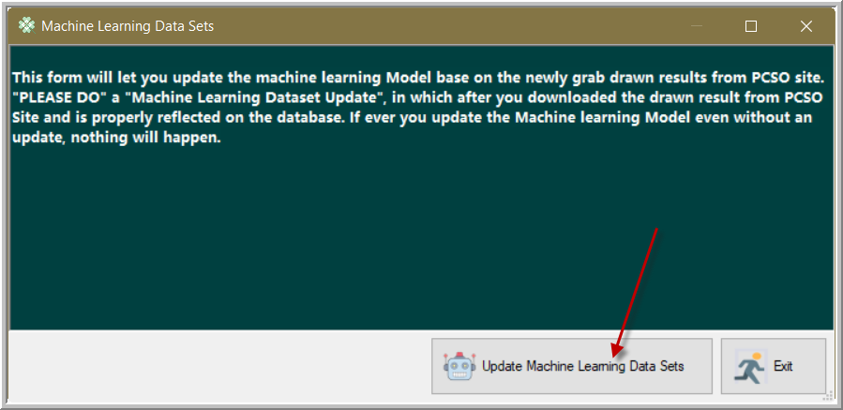

Updating in progress

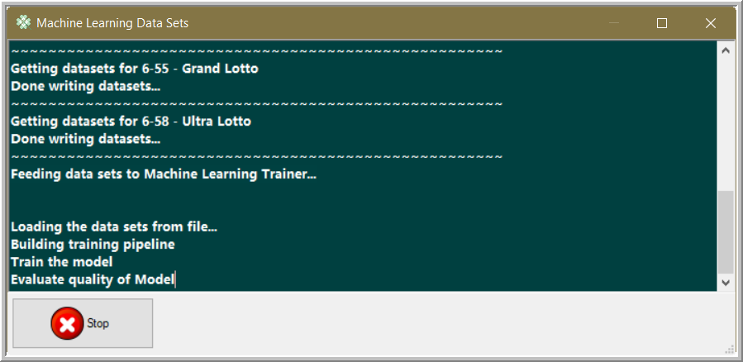

Update succeeded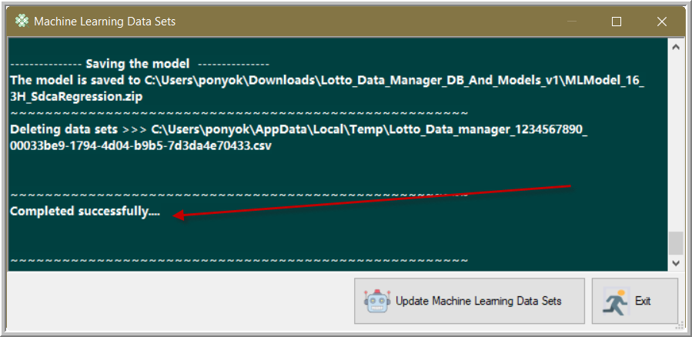

# Lotto Data Manager Updates

From time to time, check for an Updates. Cool features will be there for you as time goes by.

To open the Updates window, click the menu below.

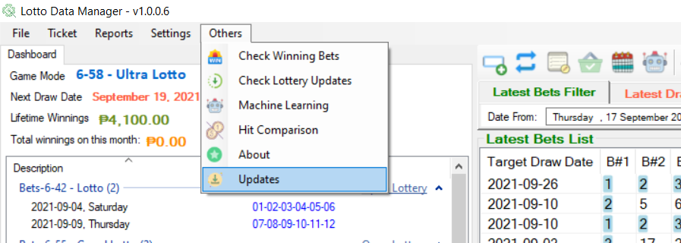

Click the Update button to start looking at the repository.

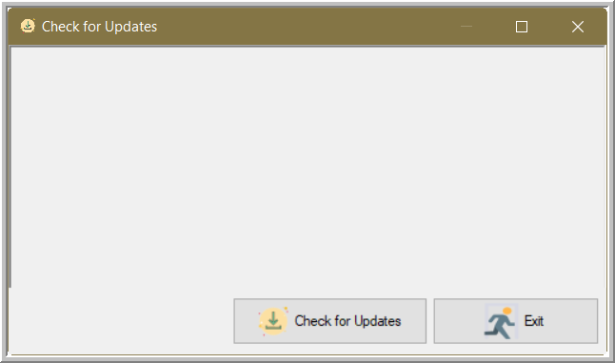

If the application is up to date, then a message “Application is up to date…” will be displayed.

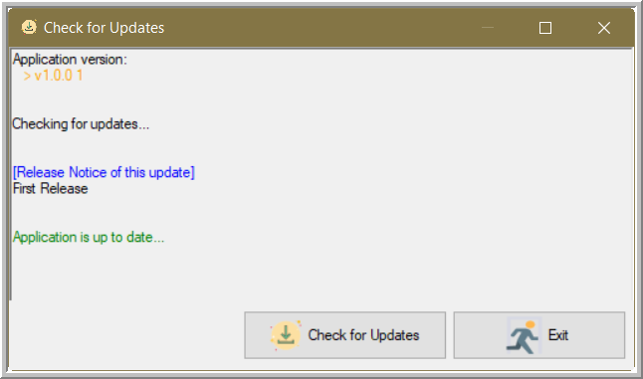

If a release is available, a link to the latest release will be given to you like below.

